**Image processing HW5 Name:武敬祥 ID:b06611032**

# GUI

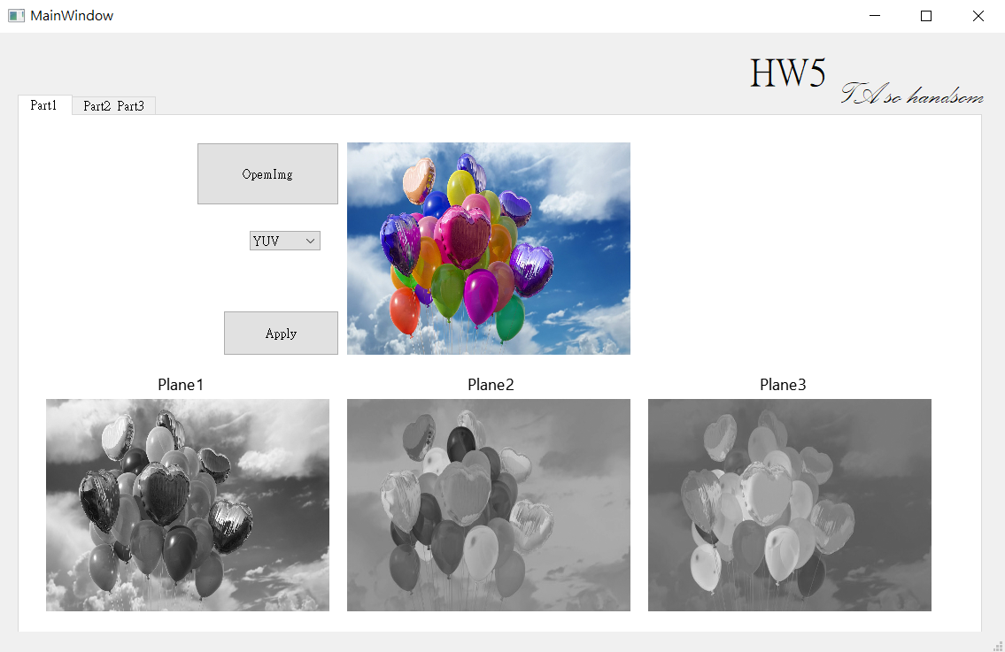

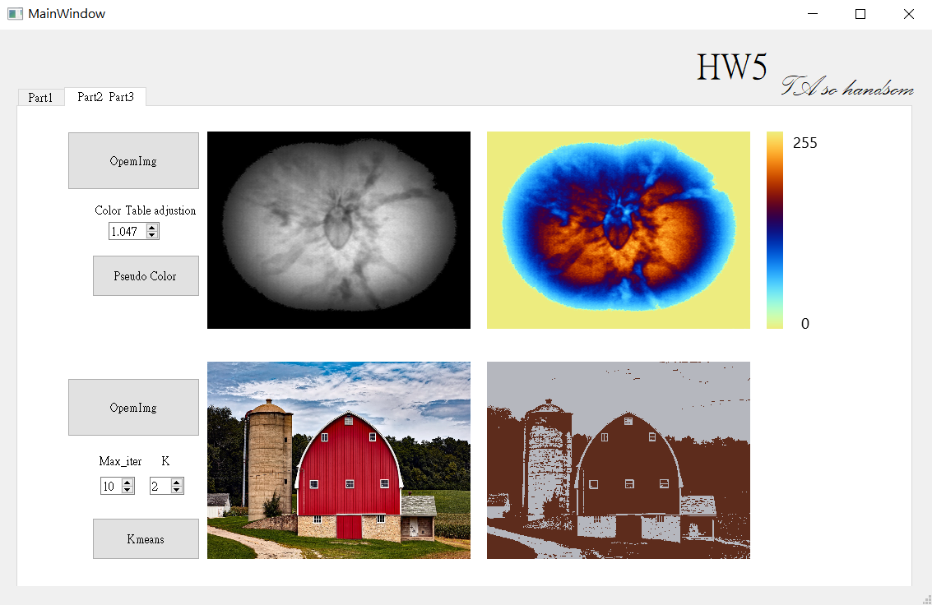

This time, I write a library-IP for image processing.

# Part 1

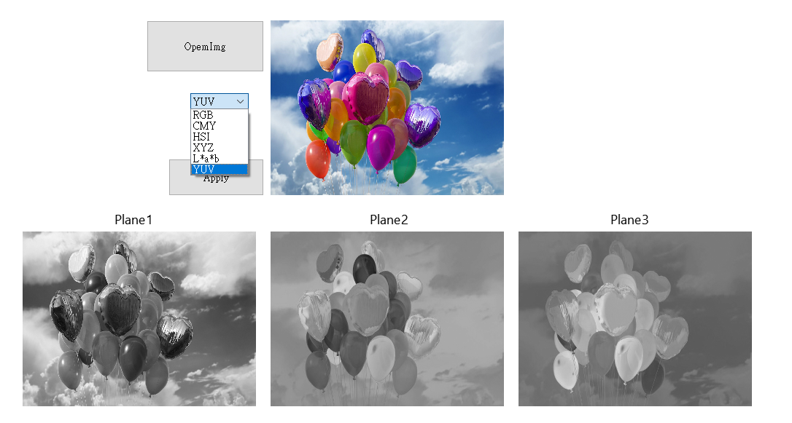

We can choose the image conversion type with the comboBox. After pressing “Apply ” button, the three color planes will display in the label below. For example, if we choose YUV, the Plane1 will display Y plane, the Plane2 will display U plane, and the Plane 3 will display V plane. The RGB, CMY, XYZ, L*a*b are in the same manner.

# Part 2

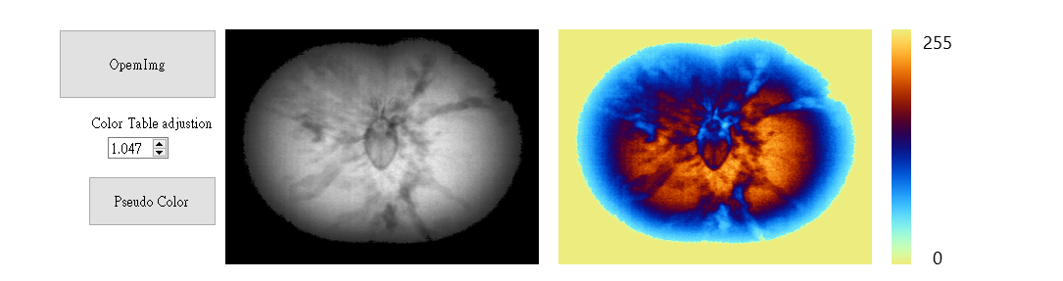

Pressing the “Pseudo Color” button can display the pseudo color image in the middle label and color table in the right label. The value 0 and 255 in the color table represents the minimum and maximum grayscale value. We can flexible adjust the color table by change the “Color Table adjustion”. There is a demonstration below.

## color table adjustion = 2.094

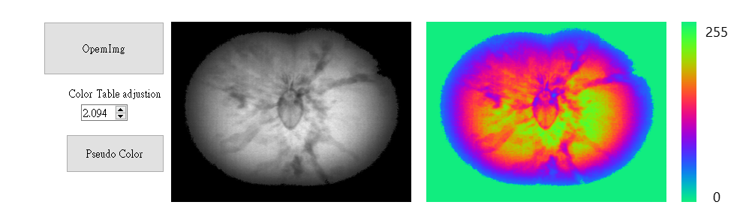

## color table adjustion = 3.141

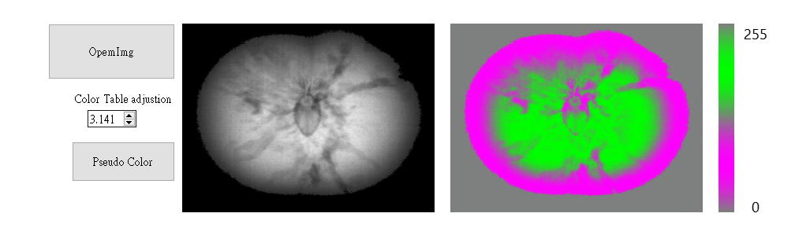

The meaning of value of “Color Table adjustion” can be clearly explained by the following diagram.

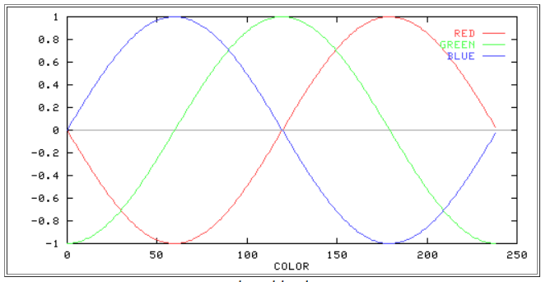

Source: <https://www.ft.unicamp.br/docentes/magic/khoros/html-dip/c4/s10/front-page.html>

I design a sinusoid mapping function from grayscale value (0,255), and the period of sinusoid just right equals to 255. Actually, the value of “Color Table adjustion” represents the phase shifting of RGB sin wave. For example, if the value equals 3.141, the G sin wave is half a period behind the R wave, and B sin wave is a whole period behind the R sin wave.

# Part 3

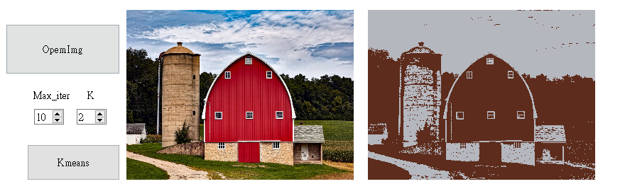

I use ready-made function kmeans in the opencv to accomplish this. We can select the value of max iteration and cluster number with “K” and “Max_iter” spinBox.

## Original

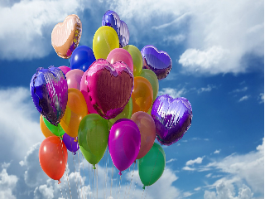 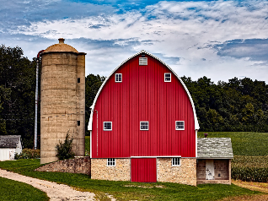

## K = 3

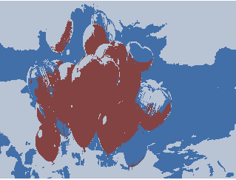 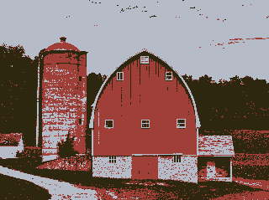

## K = 4

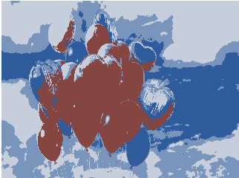 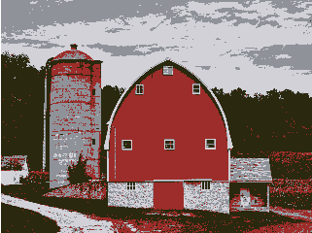

## K = 5

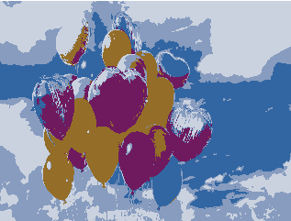 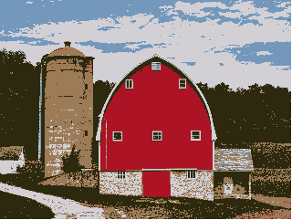

## K = 6

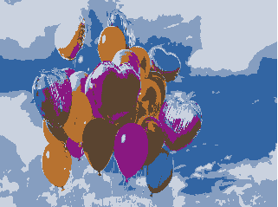 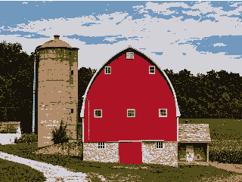

Undoubtedly, With the higher value of K, we have a better and clearer image. On the other hand, if a image with higher complexity (like the left side image), in the contrast, we need a bigger K value to construct a image than a image with lower complexity.